|  |  |
| --- | --- |
| **Titre** | Gestion de cave |
| **Nom, prénom** | Gfeller Jérémy |

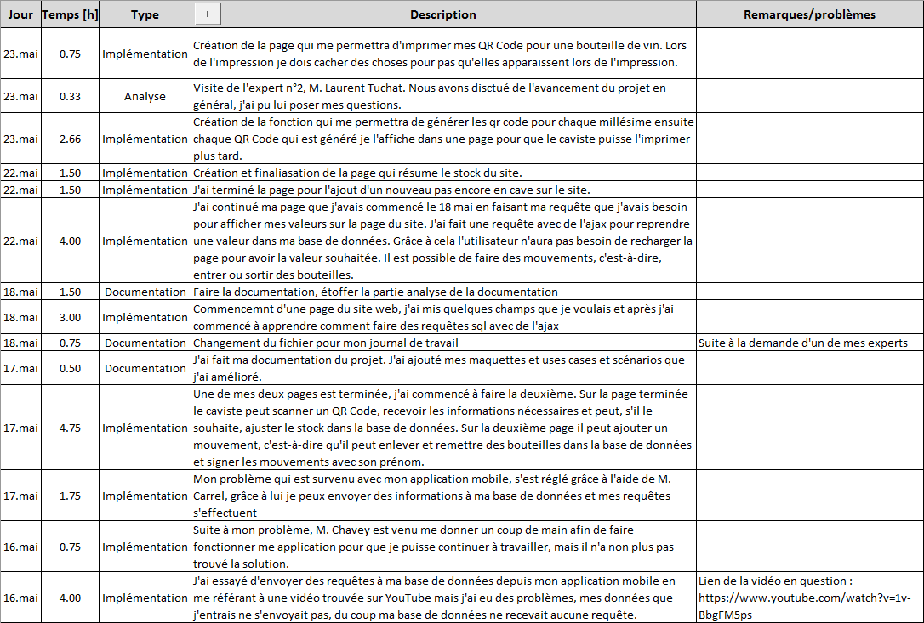

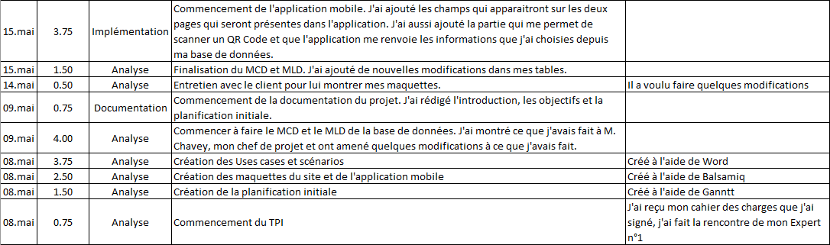

|  |  |  |  |  |
| --- | --- | --- | --- | --- |
| **Somme de Temps [h]** |  |  |  |  |
|  | **Documentation** | **Implémentation** | **Analyse** | **Total général** |
| 18.mai | 2.25 | 3 |  | 5.25 |
| 17.mai | 0.5 | 6.5 |  | 7 |
| 16.mai |  | 4.75 |  | 4.75 |
| 15.mai |  | 3.75 | 1.5 | 5.25 |
| 09.mai | 0.75 |  | 4 | 4.75 |
| 08.mai |  |  | 8.5 | 8.5 |
| 14.mai |  |  | 0.5 | 0.5 |
| 22.mai |  | 7 |  | 7 |
| 23.mai |  | 3.41 | 0.33 | 3.74 |
| **Total général** | **3.5** | **28.41** | **14.83** | **46.74** |